**EXPERIMENT NO.:1**

**Preparation of benzoic acid from toluene**

**YouTube link: https://youtu.be/b9cEfagdhSU**

***Reaction involved:***

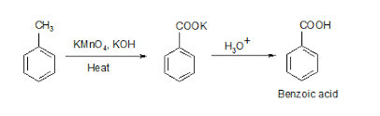

***Chemicals required:***

1. Toluene (5.1 g),

2. Potassium permanganate (17.5 g),

3. Potassium hydroxide (5mL 20% solution)),

4. Sulphuric acid (conc)

5. Sodium bisulphite

***Procedure:***

1. In a clean 250 mL three necked round bottomflask equipped with thermometer, water condenser, magnetic stir bar and dropping funnel take 5 mL of 20% KOH solution, 45 mL of distilled water and 5.1 g of toluene.
2. Place the flask in an oil bath and heat up to 850C using temperature controlled hot plate.
3. Toluene and water form azeotropic mixture which starts boiling at 850C.
4. Add KMnO4 solution (Made by dissolving 17.5 g of KMnO4 in 150 g of distilled water at 700C) to the boiling solution of toluene and water dropwise for 15 minutes using dropping funnel.
5. Allow the mixture to reflux for 1.5 hrs. If purple colour of KMnO4 persists allow the reflux for additional 15 minutes.
6. Add a few mL of ethanol to destroy excess KMnO4 present.
7. Allow the solution to cool at room temperature and filter the solution under suction.
8. Take the filtrate in a 500 mL of beaker, add a pinch of sodium bisulphite and acidify with dilute sulphuric acid.
9. White solid appeared in the beaker.
10. Filter the white solid.
11. Recrystallize the white solid from hot water (800C).
12. Record the yield and determine the melting point.

**Oxidation mechanism by KMnO4**

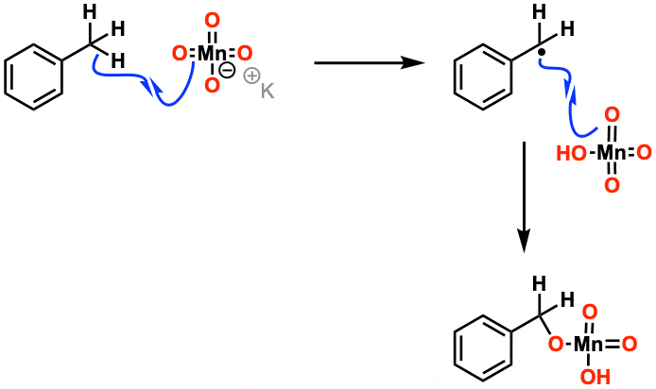

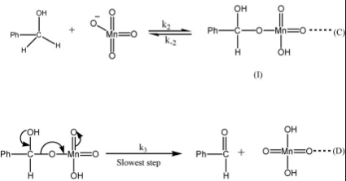

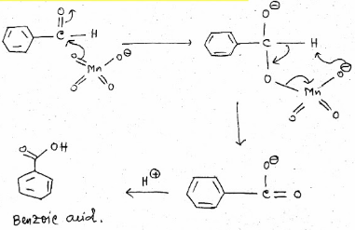

**EXPERIMENT NO.:2**

**Separation of amino acids from their mixture by Paper Chromatographic technique**

**Principle:**

Paper chromatography wherein the substances are distributed or partitioned between liquid phases. One phase is the stationary, which is held in the pores of the filter paper used and other is the mobile phase which moves over the paper.

Capillary action: the movement of liquid within the spaces of a porous material due to the forces of adhesion, cohesion, and surface tension. The liquid is able to move up the filter paper because its attraction to itself is stronger than the force of gravity.

Solubility: the degree to which a material(solute) dissolves into a solvent. Solute dissolves into solvents that have similar properties. This allows different solutes to be separated by different combinations of solvents.

Separation of components depends on both their solubility in the mobile phase and their differential affinity to the mobile phase and the stationary phase.

**Chemical required:**

1. Amino acids (L-Lysin, DL-Alanin, L-Leucine)
2. Acetic acid
3. 1-Butanol
4. Distilled water
5. Spraying reagent: Ninhydrin (0.3% solution in rectified spirit

**Apparatus:**

1. Measuring cylinder
2. Test tubes
3. Electric air oven
4. Solvent chamber (20 cm×4 cm)
5. Sprayer
6. Whatman No. 1 chromatographic paper (20 cm×4 cm)

**Procedure:**

1. **Preparation of solutions (10-15 mg of each amino acid is mixed and dissolved in 1 ml distilled water) and unknown amino acid in a separate test tube.**
2. **The chromatographic paper strip is taken and a base line is draw above 4 cm from the lower end. Spots are given with the help of the capillary tubes.**
3. **Developing solvent- Butanol: AcOH : H2O =12:3:5 and poured into the jar before 1 hr. of developing and lid is placed properly.**
4. **Development of the chromatogram.**
5. **Drying in oven.**
6. **Spraying.**
7. **Location of the spots with pencil.**

**Calculation:**

**The movement of any substance relative to the solvent front in a chromatographic system is Constance. In paper chromatography it is defined as,**

**RF value- Distance moved by the substance/distance moved by the solvent front.**

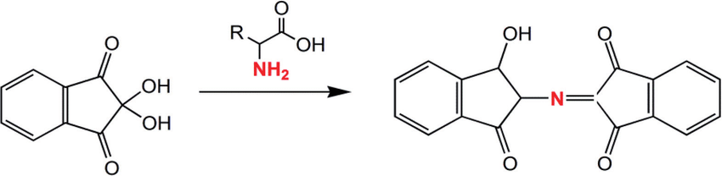

Ninhydrin

Purple colour